PHISHING EMAIL DETECTION & ANALYSIS REPORT.﻿
Future intern | Task 2﻿
Submitted by:vishnu surendran | Date: 18 May 2026﻿
1. OBJECTIVE﻿
To analyze a suspicious job offer email, identify phishing indicators using open-source tools, and document findings to determine if the email is malicious.﻿
2. TOOLS USED﻿
| Tool Name | Purpose |﻿
| --- | --- |﻿
| 1. Manual Email Analysis | To identify social engineering tactics in email content |﻿
| 2. Google Admin Toolbox - Messageheader | To verify SPF, DKIM, DMARC authentication results |﻿
| 3. VirusTotal | To check reputation of URLs found in the email |﻿
4. Browser/ISP Alert System | To validate real-time blocking of malicious links .﻿
3. CASE STUDY: SUSPICIOUS OFFER of free software though EMAIL﻿
3.1 Email Summary﻿
- From:splank.xzy.@hotmail.org﻿
- Reply-To: vsurendr1@gmail.com﻿
- Date Received: 16 Oct 2025﻿
- Suspicious URL Found: https://urlto.me/29AC2﻿
3.2 Visual Evidence﻿
Figure 1: Screenshot of the suspicious email contant .
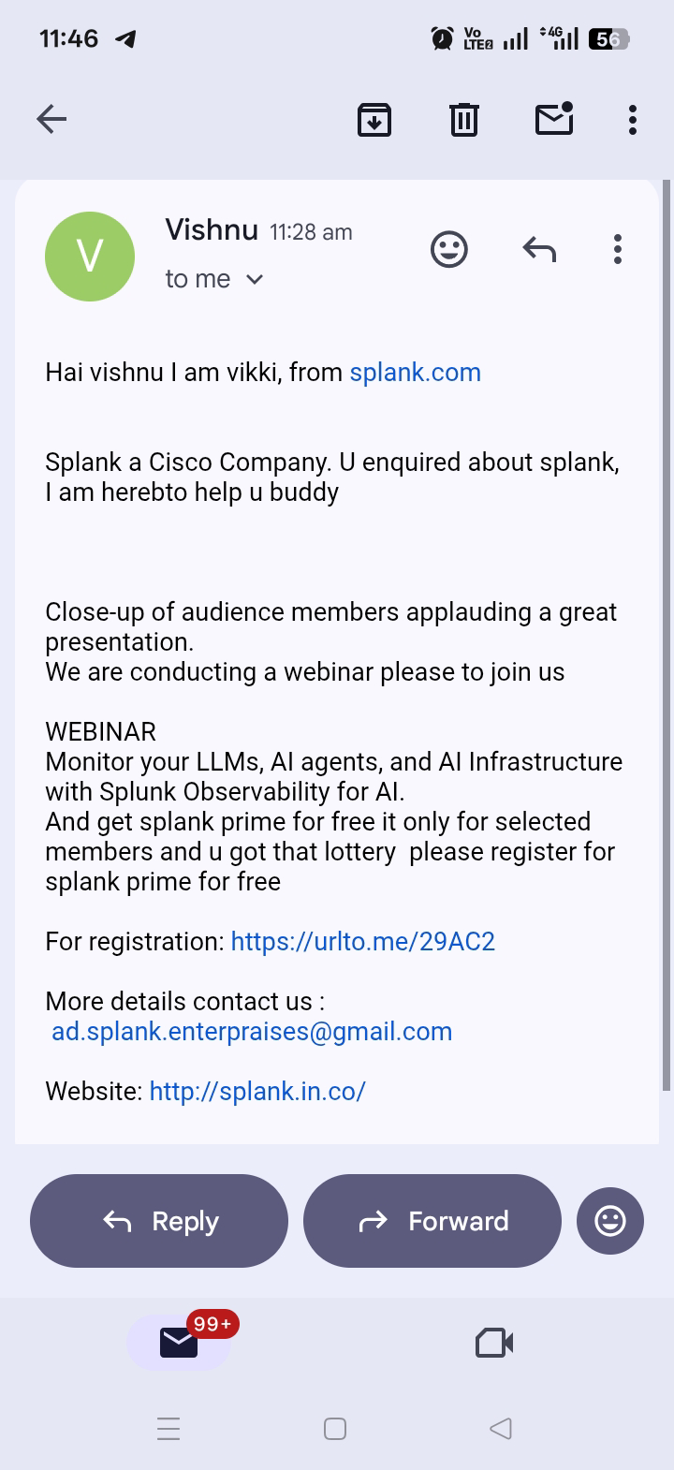
﻿
Figure 2: VirusTotal analysis of the URL `https://urlto.me/29AC2`.
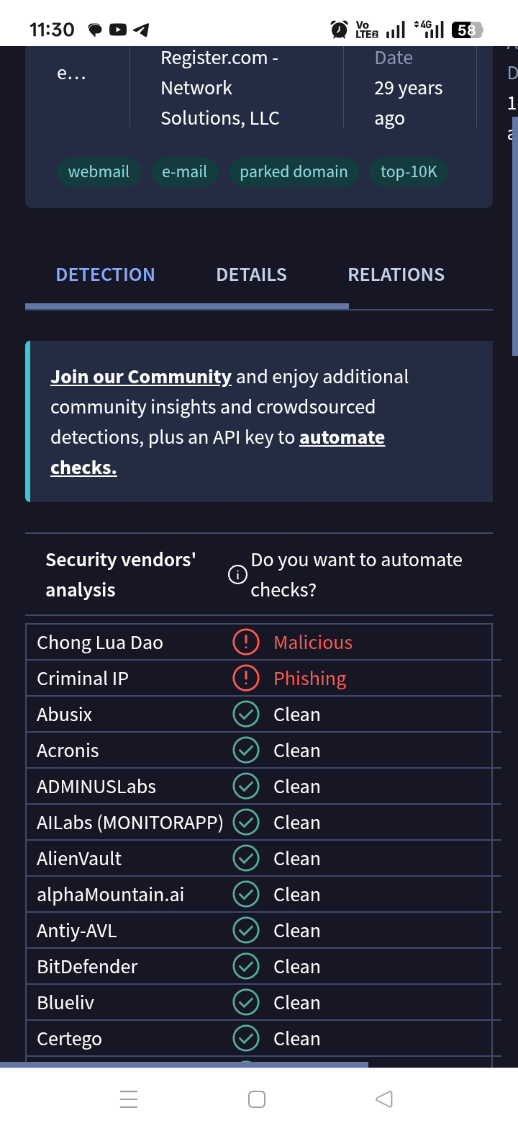
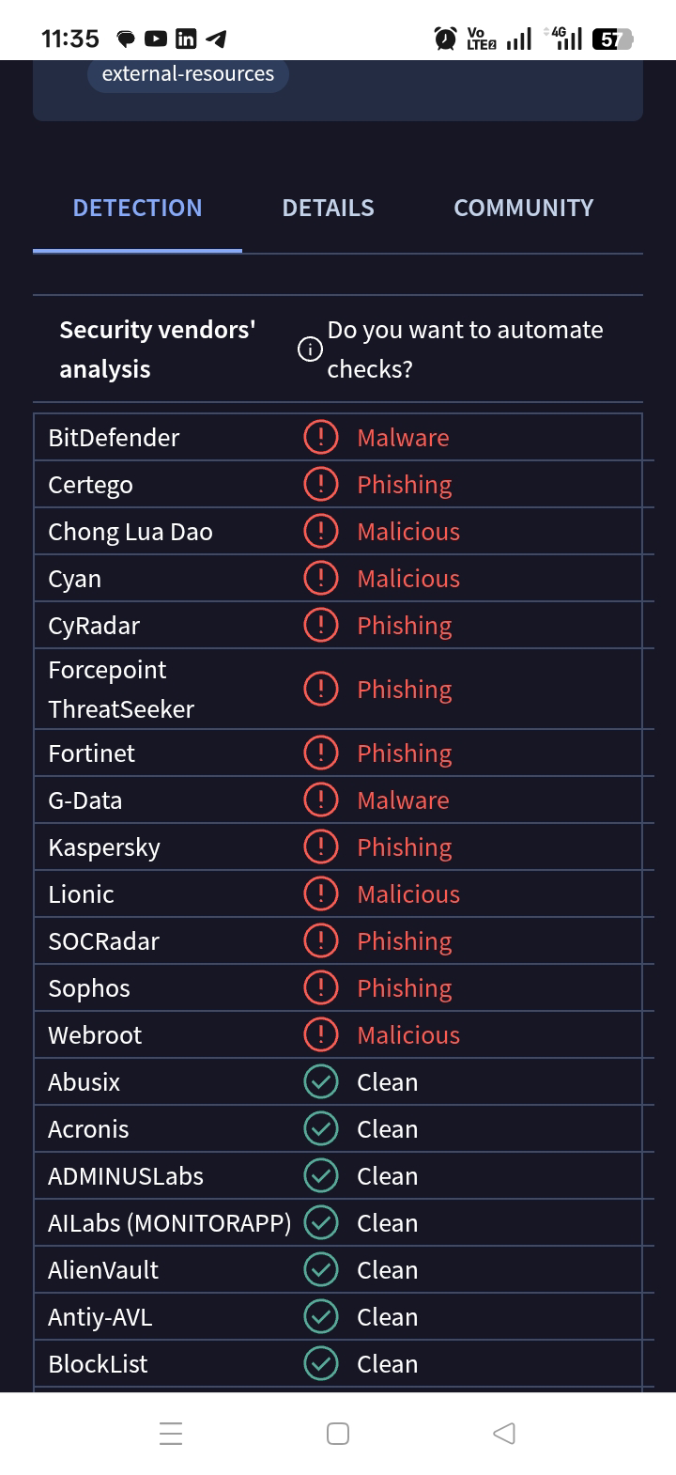
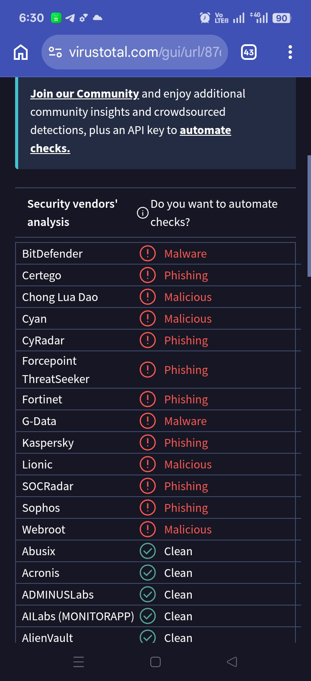
Figure 3: ISP level blocking by Vi Protect.
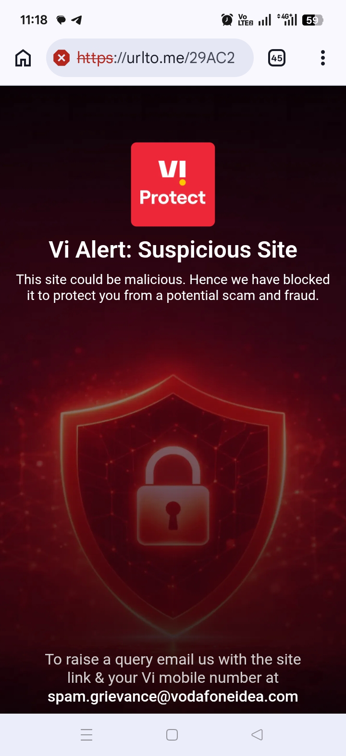
3.3 Phishing Indicator Analysis﻿
| Sl.No | Phishing Indicator | Status | Evidence & Observation | Risk Level |﻿
| --- | --- | --- |﻿
| 1 | Spoofed/Fake Sender Domain | [CHECK SPF: PASS/FAIL] | SPF/DKIM result from header analysis. | High if FAIL |﻿
| 2 | Suspicious/Malicious Link | Yes | The URL `https://urlto.me/29AC2` was flagged by 13 out of 93 security vendors including Kaspersky, Sophos, Fortinet, and BitDefender as 'Phishing' and 'Malware'. | High |﻿
| 3 | Future Date Anomaly | Yes | Email date is 16 Oct 2025, which is in the future. Used to manipulate inbox sorting. | Medium |﻿
| 4 | ISP/Network Blocking | Yes | The link was automatically blocked by Vi Protect with a "Suspicious Site" warning to prevent fraud. | High |﻿
| 5 | URL Shortener Used | Yes | Legitimate companies do not use `urlto.me` for free offers with upcoming most priced softwares. Shorteners hide the real destination. | High |﻿
3.4 Final Verdict & Recommendation﻿
Conclusion: This is a confirmed phishing attempt. The evidence is conclusive:﻿
1. The embedded link `https://urlto.me/29AC2` is malicious, verified by 13 major antivirus engines on VirusTotal.﻿
2. The link was actively blocked by the ISP Vi Protect to prevent user access.﻿
3. The use of a future date and a generic URL shortener are classic phishing tactics.﻿
Recommendation: Delete the email immediately. Do not click any links or download attachments. Do not provide any personal or financial information. Report the email as phishing to your email provider and to the cybercrime portal at cybercrime.gov.in.﻿
4. BEST PRACTICES TO PREVENT PHISHING﻿
1. Always Verify Links: Use VirusTotal to check any suspicious URL before clicking.﻿
2. Check Sender Authentication: A FAIL in SPF/DKIM is a major red flag.﻿
3. Beware of URL Shorteners: Legitimate job offers will link directly to the company domain, not `bit.ly` or `urlto.me`.﻿
4. Trust Browser/ISP Warnings: If you see a "Suspicious Site" or "Deceptive Site" warning, close the page immediately.﻿
5. Never Pay for Jobs: No legitimate employer asks for money for registration or offer letters.﻿
---﻿
End of Report

